St. Vincent Pallotti College of Engineering and Technology, Nagpur
Department of Computer Science and Engineering (Data Science)
ACTIVITY REPORT 2025-2026

Title of Project: Contact Management System Using Linked List
Student Name: Aaron Geevarghese Mathews, Ann Leo Roll No: 24006052, 24006054
Sem: 4th Semester, 2nd Year
Date of Submission: 28-04-2026
-------------------------------------------------------------------------------------------------------
Objective
The Contact Management System is a console-based application developed using the C programming language. The primary objective is to efficiently store, manage, and manipulate contact information such as names and phone numbers. It demonstrates practical implementation of data structures specifically the singly linked list to handle dynamic data. The system also integrates file handling to ensure data persistence across sessions.

Methodology / Algorithm
- Initialize the program and load existing contacts from contacts.txt into a singly linked list.
- Display a menu-driven interface for user interaction (Add, View, Search, Update, Delete, Sort, Stats).
- For insertion: dynamically allocate memory for a new node, store name and phone number, and prepend to the list. Check for duplicates before inserting.
- For traversal: traverse from the head node and display each contact's details.
- For search: traverse the list and compare by exact/partial name or phone number.
- For deletion: locate the target node, update the previous node's pointer, and free the deleted node's memory.
- For sorting: apply alphabetical comparison to reorder nodes (ascending/descending).
- Save all changes back to contacts.txt after every modification to ensure persistence.

Tools & Technologies Used
- Language: C Programming
- Data Structure: Singly Linked List
- File Handling: Plain-text file (contacts.txt)
- Memory Management: Dynamic allocation using malloc() and free()
- IDE/Compiler: GCC / any standard C compiler
- UI: Console/Terminal with colored output and loading animation

Main Concept of the Project
The core concept is using a Singly Linked List as the primary data structure to dynamically store contact records. Each node holds a contact's name, phone number, and a pointer to the next node. This allows flexible insertion and deletion without memory wastage, unlike fixed-size arrays. File handling (contacts.txt) is integrated to persist data across sessions. The system supports full CRUD operations, partial-name search, duplicate prevention, alphabetical sorting, and contact statistics — all through a menu-driven console interface.

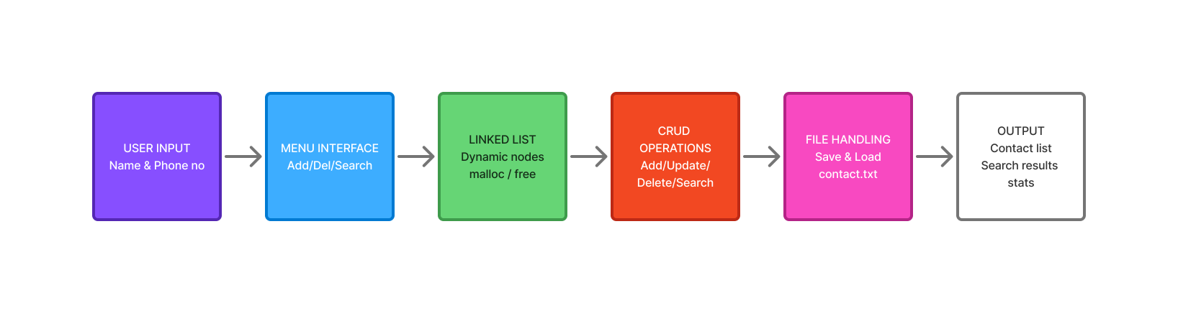

Features of the Project
Feature | Description
Menu-driven Interface | User-friendly, easy to navigate
Dynamic Data Handling | Linked list for flexible memory management
File Storage | Permanent data via contacts.txt
Duplicate Prevention | Prevents adding duplicate contacts
Partial Search | Search by partial name or phone number
Sorting | Ascending & Descending alphabetical order
Statistics | Displays total contact count
Colored UI | Loading animation and colored terminal output

Advantages
Advantage | Details
Efficient Memory Usage | Only allocates memory for actual contacts
Easy Insertion & Deletion | No shifting of elements like in arrays
Scalable System | Can handle any number of contacts dynamically
Readable Logic | Simple and understandable implementation

Limitations
Limitation | Impact
No Graphical User Interface | Command-line only; no GUI interaction
Linear Search Performance | O(n) time complexity for search operations
Not Suitable for Large Datasets | Performance degrades with thousands of records

Output
Menu-driven terminal interface showing options: Add Contact, View All, Search, Update, Delete, Sort, Statistics, Exit.
Sample: Adding 'John Doe, 9876543210' → 'Contact added successfully!' Viewing all contacts lists each entry with name and phone number, total count shown in statistics.

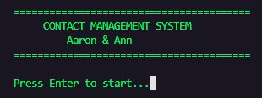
Figure 1: Startup Screen - Welcome screen displayed when the program is launched

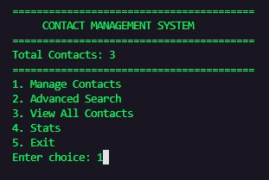
Figure 2: Main Menu - Shows total contacts and navigation options

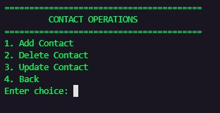
Figure 3: Contact Operations Menu - Add, Delete, Update options

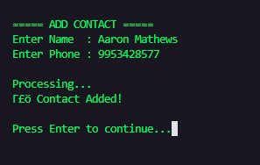
Figure 4: Add Contact - Input and confirmation of new contact entry

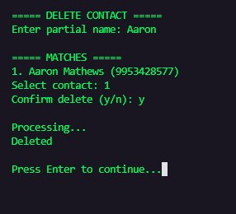
Figure 5: Delete Contact - Search, select and confirm deletion

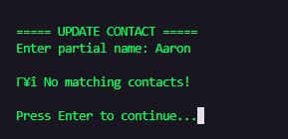
Figure 6: Update Contact - No matching contact found scenario

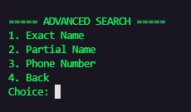
Figure 7: Advanced Search - Search type selection menu

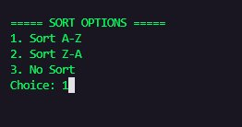
Figure 8: Sort Options - Alphabetical sort direction selection

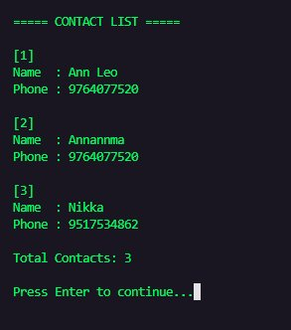
Figure 9: Contact List - All contacts displayed with details

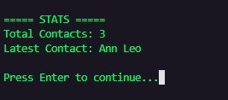
Figure 10: Stats - Total contact count and latest contact

Result
The Contact Management System was successfully implemented in C using a Singly Linked List. It performs all CRUD operations with file persistence, supports partial search and alphabetical sorting, and prevents duplicate entries demonstrating effective use of data structures and memory management.

Faculty Coordinator:

Prof Kalyani Satone Dr Nischal Puri

